# Subsetting by Row/Column Number

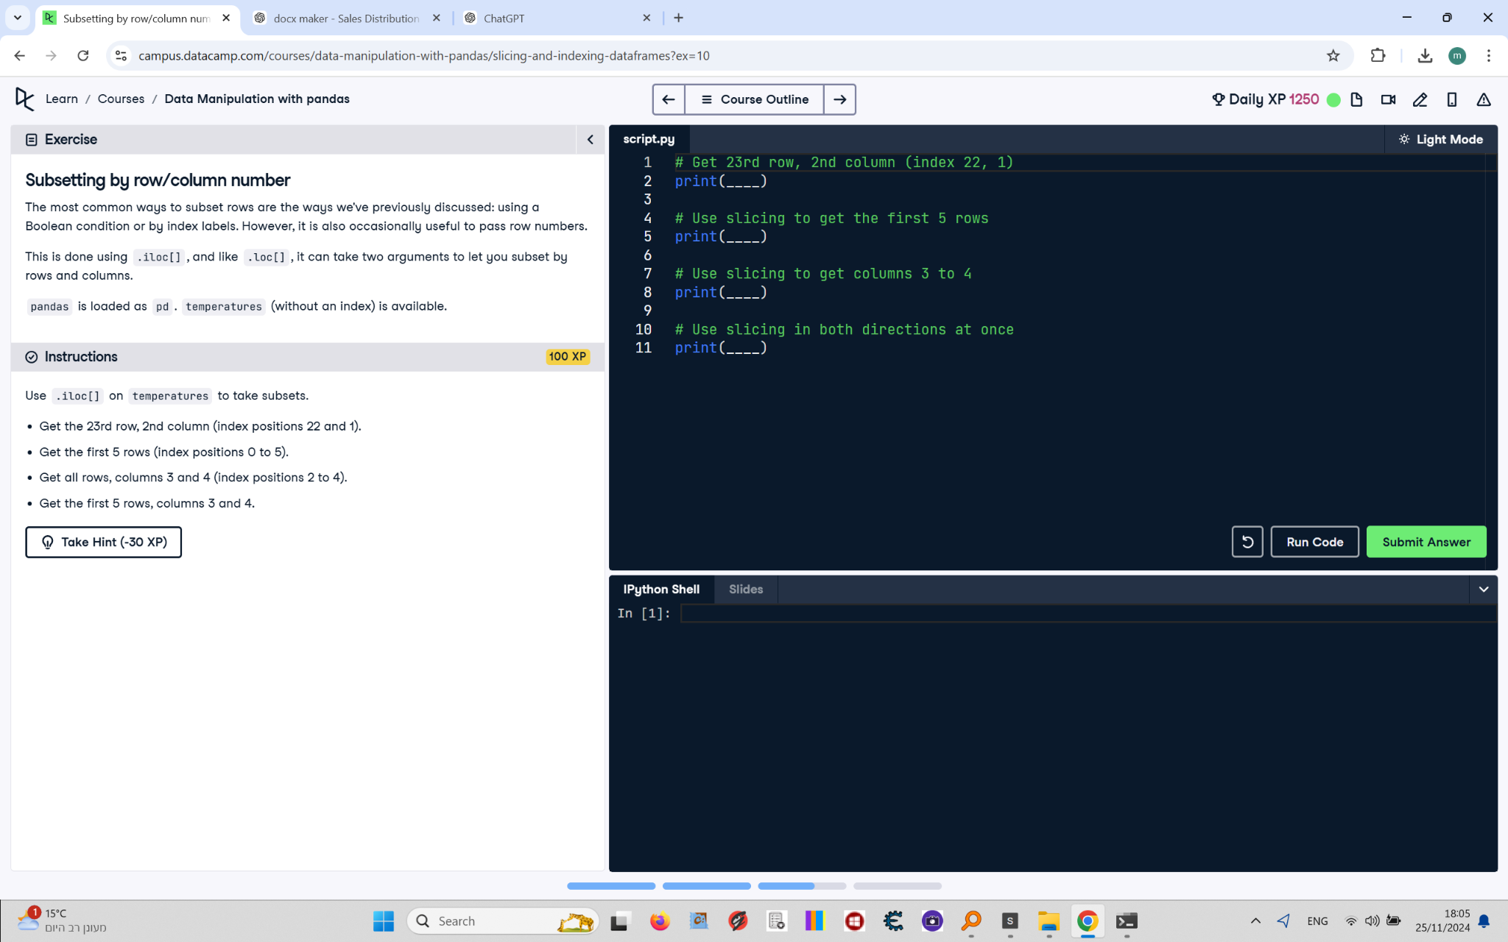

The most common ways to subset rows are the ways we've previously discussed: using a Boolean condition or by index labels. However, it is also occasionally useful to pass row numbers. This is done using .iloc[], and like .loc[], it can take two arguments to let you subset by rows and columns.  
  
pandas is loaded as pd. temperatures (without an index) is available.

## Final Answer

# Get 23rd row, 2nd column (index 22, 1)  
print(temperatures.iloc[22, 1])  
  
# Use slicing to get the first 5 rows  
print(temperatures.iloc[0:5])  
  
# Use slicing to get columns 3 to 4  
print(temperatures.iloc[:, 2:4])  
  
# Use slicing in both directions at once  
print(temperatures.iloc[0:5, 2:4])